24 Port 1U Vertical Rackmount CAT5e UTP Patch Panel Plus Back Bar (PPAN-24-VLC)

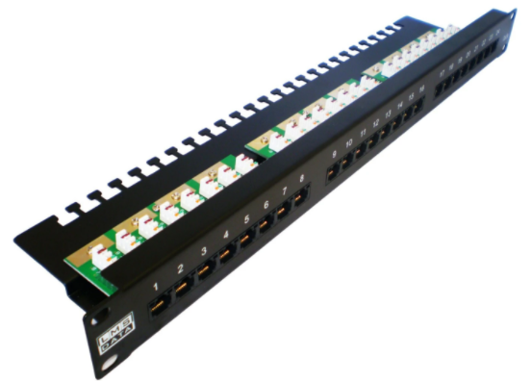

Description:
The LMS Data PPAN-24-VLC is 24 Port certified CAT5e UTP Patch Panel which is ideal for structured cabling installations in offices of all sizes. Slim line, 1U height means its ideal for small wall cabinets as well as regular, floor standing cabinets and racks. Using a horizontal IDC rear punchdown means its easy to to terminate cables by simply pulling the patch panel from the front of the cabinet its installed in.
Fully Gigabit Ethernet certified means its ideal for running legacy and advanced networking protocols to Gigabit Switches up up to 1000Mbps. Also ideal for telecom, VoIP, CCTV-IP and other Ethernet based standards.
Long-life, nickel plated female RJ45s, robust construction with colour-coded rear Krone(tm) KATT type IDC for both TIA-568A/B terminations.

Setting new standards in both performance and quality, the new LMS Data PPAN-24-VLC Vertical Punch down Patch Panel series offers full Cat5e compliance with up to Gigabit Ethernet compliance if your network requires it. Designed into a durable, full metal open chassis, this 24-Way, 1U high design is ideal for quick termination to the vertical IDC interconnect blocks and is the perfect match for Wall Mount enclosures which have little or no space for the regular rear facing IDC Patch Panels or other locales were space is at a minimum. The LMS Data PPAN-24-VLC comes complete with rear cable anchor tabs; full TIA-568-A/B termination colours and front port number sequence. Ideal for both Data and Telecom applications, the Patch Panel is also incorporated under the Synthesis 25-Year structured cabling warranty for full piece of mind.

Key Features:
- Certified CAT5e Performance for Gigabit Ethernet
- Popular Krone(tm) KATT Dual Purpose IDC Punchdown
- Vertical Punch Down Method Means Easier Installation
- Part of the Synthesis 25-Year Warranty Solution
- Vertical Punch down system for easy install
- Class-leading CAT5e/ISO-11801 compliant
- Supports 22 to 26AWG in solid and stranded wires
- TIA-EIA-568A or B punch down IDC blocks
- 1U high, full metal open chassis for robust use
- Rear built-in cable management tabs
- Ideal for Wall Cabinets and restrictive usage
- Available under the 25-Year System Warranty

Applications:
- Office, Education and Home Structured Cabling Installs
- Ideal for Gigabit Ethernet (1000Mbps) Data Networks
- Create fault tolerant LANs by simply patching ports

Product Code:
- Part Number: PPAN-24-VLC
- EAN: 8400800032195
- Weight: 1 Kg approx

Technical Specifications:
- Port Count:24 Ports UTP
- Dimensions :1U 19-Inch Design Format
- Conformance: TIA-EIA-568A/568-B Coded IDC
- Performance:10/100/1000Mbps Gigabit Compliance
- RJ45/IDC Connects: Nickel and Phosphor Bronze
- Port Identification:Numbered and Bespoke ID Marker
- Fixings:Supplied M6 Nuts and Bolts
* Specifications and product design are subject to change. E&OE.

